Cardiff Council Clean Air Bus Retrofit Scheme
2020- 21

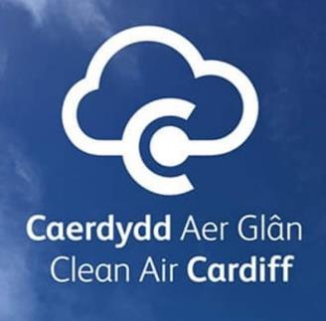



October 2020

INVITATION TO APPLY
(ITA)
FOR
Clean Bus Retrofit Scheme 2020- 21

GRANT FUNDING REF: Cardiff Clean Bus Retrofit Scheme 2020- 21

Cardiff Council
Clean Air Project Team
County Hall,
Cardiff,
CF10 4UW

October 2020

REF: Cardiff Clean Bus Retrofit Scheme - INVITATION TO APPLY FOR GRANT FUNDING FOR CARDIFF COUNCIL’S CLEAN BUS RETROFIT SCHEME 2020- 21

- Local authorities have a statutory duty under Part IV of the Environment Act 1995 & Air Quality Strategy for England, Scotland, Wales and Northern Ireland 2007 to manage local air quality. Under Section 82 of the Environment Act 1995 the Local Air Quality Management (LAQM) process places an obligation on all local authorities to regularly review and assess air quality in their areas, and to determine whether or not air quality objectives are likely to be achieved.

- There are currently four Air Quality Management Areas (AQMAs) declared across Cardiff which have all been declared due to exceedances of the annual mean NO₂ Air Quality Standard (40ug/m³), known to be derived from road transport.

- Two AQMAs are primarily focused in Cardiff City Centre: Cardiff City Centre AQMA, established 01/04/2013 and Stephenson Court AQMA, established 01/12/2010.

- North of the City Centre, lies the Llandaff AQMA (established 01/04/2013) and to the west of Cardiff is the Ely Bridge AQMA (established 01/02/2007).
Figure 1- Boundary of Cardiff City Centre AQMA
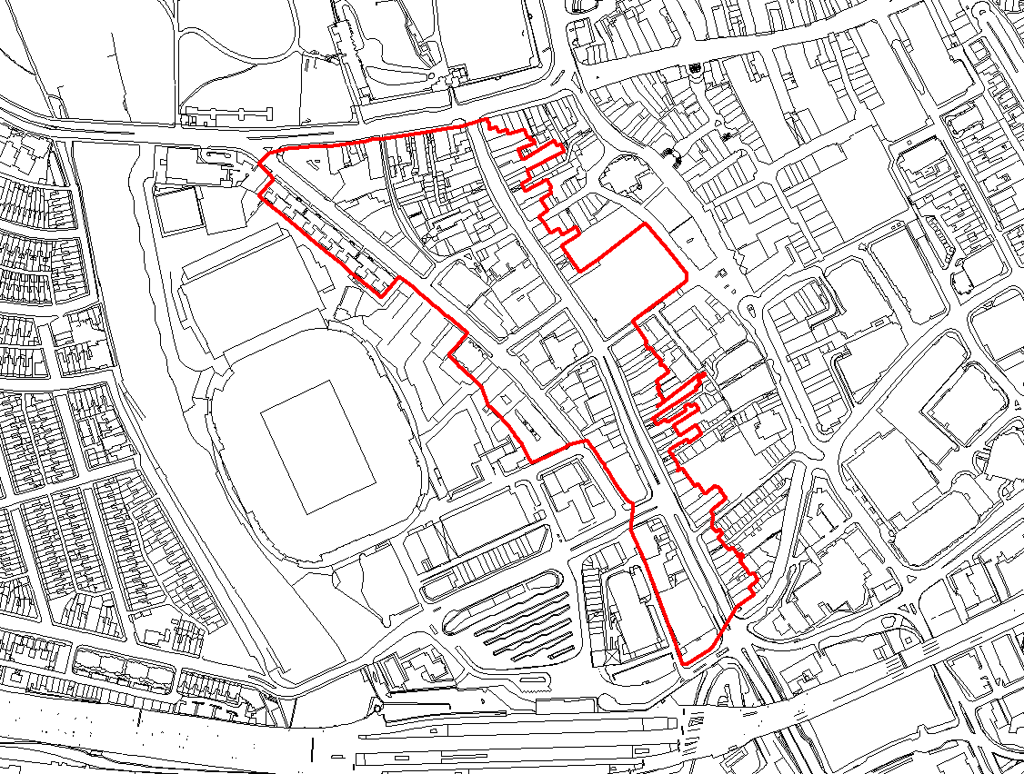

Figure 2- Boundary of Ely Bridge AQMA
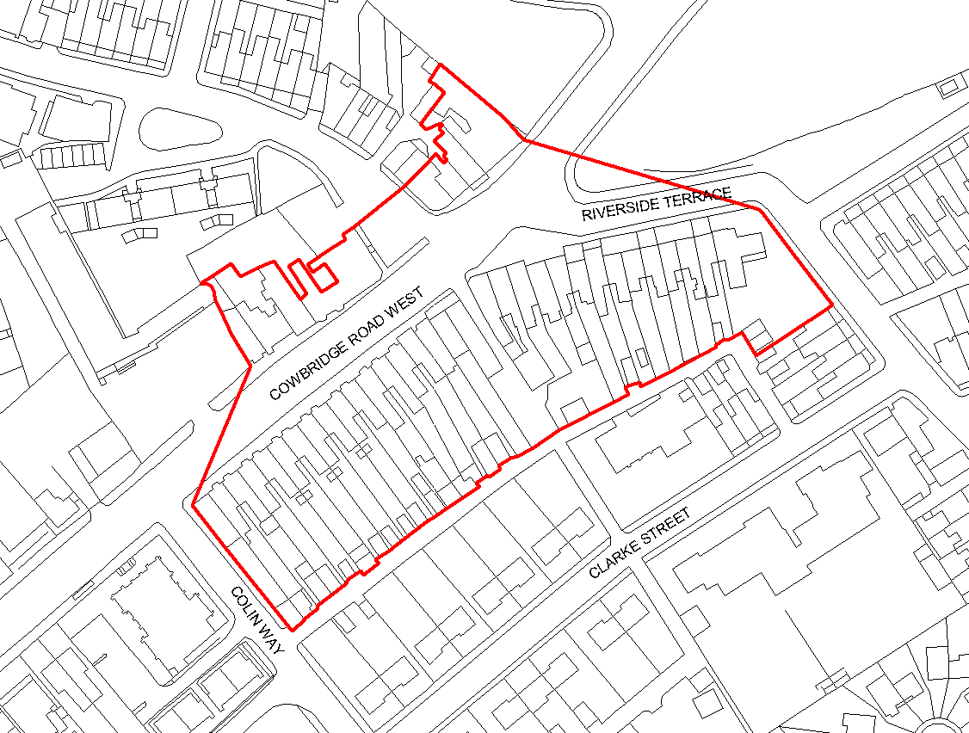
Figure 3- Boundary of Stephenson Court AQMA

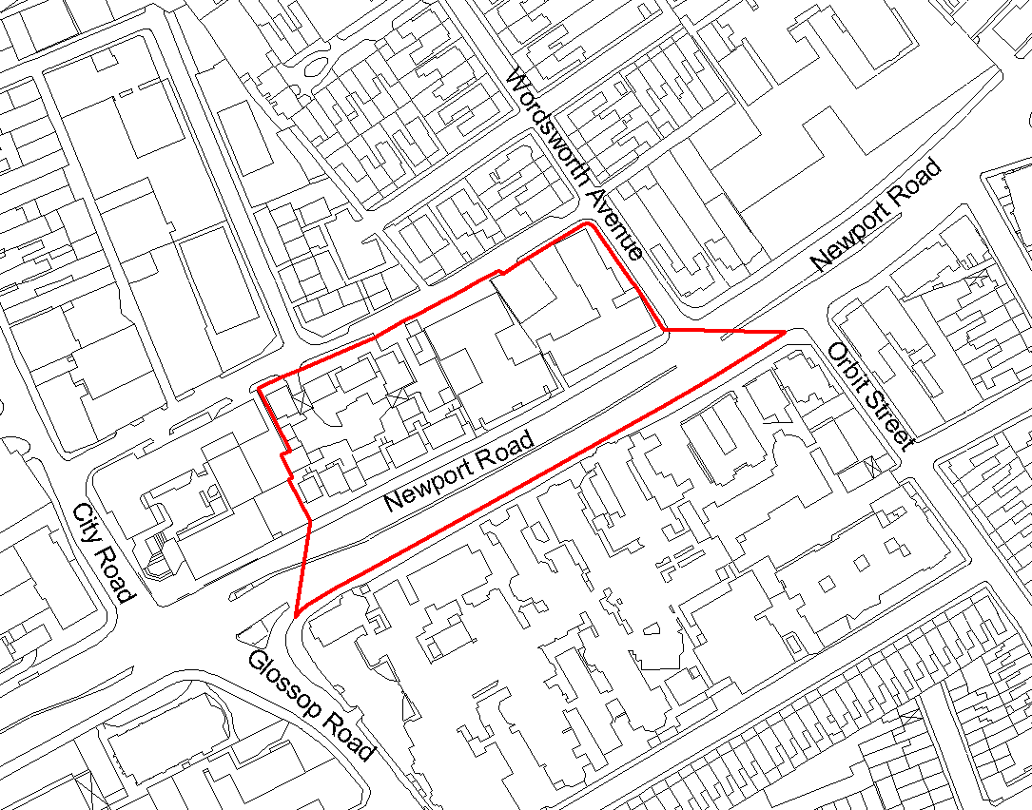

Figure 4- Boundary of Llandaff AQMA
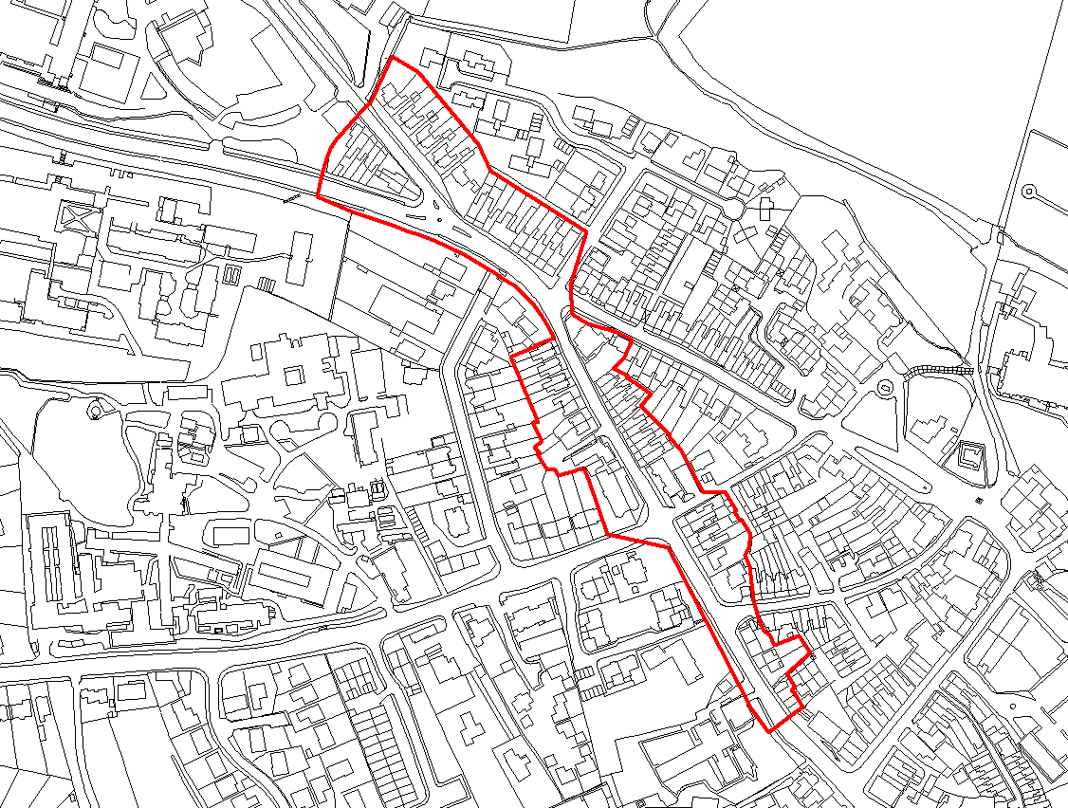

- In addition to Cardiff’s 4 AQMAs, the UK and devolved Governments have, since 2010, had a legal obligation to achieve a nitrogen dioxide (NO2) annual average limit value of 40µg/m³ as set out in the EU Ambient Air Quality Directive (2008/50/EC) in the shortest possible time.

- The UK published an Action Plan in December 2015 that was successfully challenged in High Court by Client Earth in 2016 for not meeting the requirements of the Directive.

- As a result of the High Court Ruling the UK Government had to redraft and publish a new UK Action Plan, issued in July 2017. Cardiff was identified as an area with persistent non-compliance beyond 2020.

- As a result of the detail in the UK Plan, and a subsequent High Court ruling, in March 2018, under Part IV of the Environment Act 1995, Section 85(7), WG issued a formal direction to CC to address its air quality concerns, with particular reference to 5 specific road links (A4161, the A4232, the A4234, the A470 and the A48). The direction has been governed by the Welsh Minister for Environment who has determined that the direction deemed necessary to meet obligations placed upon the United Kingdom under the EU Ambient Air Quality Directive (2008/50/EC).

- In response to the legal Direction Cardiff Council put together a project team that has undertaken detailed air quality and transport modelling across the city to forecast nitrogen dioxide levels. In contrary to the initial understanding for 5 non-compliant links, the results have identified only one street where EU legal limits are likely to be breached in future years (A4161- Castle Street).

- To take action to reduce pollution levels (nitrogen dioxide - NO2) to the legal limit in the shortest possible time, the Council published its Full Business Case (Final Plan) to Welsh Government for review and hopeful funding. The Final Plan illustrates early intervention measures as well as aspired measures the Council are endorsing to improve localized air quality on the outlined A4161 Castle Street with a vision of improving citywide air quality levels. These measures include;

- Implementation of Electric Buses – 36 Electric Buses to be implemented on a number of routes within the City Centre;
- Bus Retro-Fitting Programme;
- Taxi Licensing Policy and Mitigation Scheme;
- City Centre Transportation Improvements ; and
- Active Travel Measures.

- This grant funding specifically supports the implementation of the Bus Retro-Fitting Programme.

- Cardiff Council invite you to apply for the applicable grant funding scheme, for funding to support projects to retrofit buses with technology accredited to reduce tailpipe emissions of nitrogen oxides. The opportunity is open to all bus and coach operators, operating services in Cardiff. Cardiff Council’s Clean Air Project Team will manage, regulate and fund such a retro-fit scheme with Cardiff based bus operators.

- The retro-fit programme would see applicable bus vehicles fitted with the necessary upgrades to produce an emissions output equivalent to a Euro VI vehicle. Adhering to a number of conditional criteria, to successfully qualify for the provided funding it is a main requirement that those vehicles identified for the accredited technology upgrades are expected to be operational for a further 150,000 miles or operational for minimum of 5 years after the relevant upgrades.

- For each successful application operators would be expected to spend the funding before 31st March 2021. Any need to extend this programme would be need to be approved by the Council following confirmation from Welsh Government.

- Cardiff Council received legal advice that the implementation of the Cardiff Bus retrofit scheme accounted as State Aid and accordingly with support from Welsh Government State Aid team have notified the Commission of the scheme. Subsequently the Commission approved the scheme, in August 2020. The approved scheme currently only allows for the Grant to contribute to 80% of the retrofit costs.

- In terms of procuring a supplier for the accredited technology this will be the responsibility of the bus operator, therefore no direct procurement will be undertaken by the Council. It must be noted, in line with the Clean Vehicle Retrofit Accreditation Scheme (CVRAS), using the CVRAS register, various products and suppliers can be located to support and facilitate individual operator needs.

- Applications will be scored accordingly with respect to four key aspect areas; Strategic Alignment, Delivery of Air Quality Benefits, Deliverability & Value for Money.

- This letter and its’ Annexes set out the scope of the above grant funding scheme. These explain the criteria against which projects will be assessed, the arrangements for supplying information in support of applications, the procedure for issuing grant payments, reporting requirements, and the monitoring and evaluation arrangements for approved projects.

- The full set of documents to refer to are listed below:
a) This Covering Letter
b) SECTION 1: ITA Particulars and Conditions of Application
c) SECTION 2: Instructions for Submission
d) SECTION 3: Specification of Requirements
e) SECTION 4: Technical Questionnaire Evaluation Criteria
f) APPENDIX A: Form of Agreement
g) APPENDIX B: Non Collusive Proposal Agreement

- Please read the Instructions for Submission (Section 2) of the Invitation to Apply carefully since failure to comply with the procedures contained therein may invalidate your Application.

- Any request for clarification about the requirement or funding application process should be submitted via Cardiff’s Clean Air Project Team inbox; CleanAirProject@cardiff.gov.uk and in any event no later than the deadline for clarification questions on 14th October 2020.

Section 1

ITA PARTICULARS AND CONDITIONS OF APPLICATION

SECTION 1- ITA PARTICULARS AND CONDITIONS OF APPLICATION

GLOSSARY

Unless the context otherwise requires, the following words and expressions used within this Invitation to Apply shall have the following meanings (to be interpreted in the singular or plural as the context requires):

TERM | MEANING
“Accredited Technology” | means retrofitting technologies that have been accredited to reduce emissions of nitrogen oxides through the Clean Vehicle Retrofit Accreditation Scheme (CVRAS)
“Applicants” | means the organisations being invited to respond to this ITA.
“Application Submission(s)”, or “ITA,Submission, or Funding Application” | means a Applicant’s formal proposal in response to this ITA.
“Capital Costs” | means costs incurred acquiring fixed assets, such as technology and equipment. As opposed to resource spending which means money that is spent on day to day resources and administration costs.
“Conditions of Application” | means the terms and conditions set out in this ITA relating to the submission of an Application.
“Due Diligence Information” | means the background and supporting documents and information provided by The Council for the purpose of better informing the Applicants’ responses to this ITA.
“EIR” | means the Environmental Information Regulations 2004 (as amended) together with any guidance and/or codes of practice issued by the Information Commissioner or relevant Government department in relation to such regulations.
“FOIA” | means the Freedom of Information Act 2000 (as amended) and any subordinate legislation made under such Act from time to time together with any guidance and/or codes of practice issued by the Information Commissioner or relevant Government department in relation to such legislation.
“Grant Agreement” | means the agreement to be entered into by The Council and the Applicant following any award under the funding application process.
“Invitation to Apply” or “ITA” | means this invitation to apply document and all related documents published by The Council and made available to Applicants and includes the Due Diligence Information.
“Council” | means:  (a) Cardiff Council
“Local bus service” | means one which is available to members of the general public, has scheduled stopping places and which members of the public can find out about (including where and when they can catch the bus).
“Recipient” | means the successful Applicant(s) who will be a party to the Grant Agreement and receive funding for their project

- GENERAL

  - As part of Cardiff Council’s Clean Air Plan, the Council is looking to award up to £1.8 million grant funding to bus companies operating services in Cardiff for the delivery of projects in 2020/21 to support bus modifications using Accredited Technologies.
  - The Council is accepting applications for this grant by completion of this ITA and submission via email to CleanAirProject@cardiff.gov.uk
  - Applicants are required to complete and submit the Technical Questionnaire in accordance with Section 1 (Grant Particulars and conditions of Application), Section 2 (Instructions for Submission), Section 3 (Grant Scheme and Applicant Eligibility) and Section 4 (Technical Questionnaire Evaluation Criteria) of the ITA document.
  - The information contained in the ITA is designed to ensure that a completed Application Submission is given equal and fair consideration. It is important that Applicants provide all the information asked for in the format and order specified.
  - Applicants should read the ITA carefully before submitting an ITA Response. Failure to comply with the instructions for completion and submission of an ITA Response may result in elimination from the application process. Applicants are advised to acquaint themselves fully with the Grant Scheme in section 3 and the conditions of applying in section 1. These instructions constitute the Conditions of Application. Participation in this application process automatically signals that the Applicant accepts these Conditions.

- TIMETABLE

Issue Invitation to Apply (ITA) | 1st October 2020
Deadline for clarification questions from Applicants | 14th October 2020
Deadline for Application Submissions | 31st December 2020
Evaluation of Applications Ends | 8th January 2021
Funding award notification | 11th January 2021
Funding start date | 11th January 2021
Interim reports | Every month after project inception until completion
Funding end date | 31st March 2021
Final Report Submission | 31st March 2021

- CONDITIONS APPLYING TO THIS ITA

  - Unless stated otherwise in this ITA or in writing from the Council, all communications from Applicants (including Applicants, sub-contractors, consortium members, consultants and advisers) during the period of this competitive grant exercise must be undertaken using the CleanAirProject@cardiff.gov.uk email address.

Enquiries and Communication relating to this ITA.

  - Any request for clarification about the requirement or funding application process should be submitted at the earliest opportunity via the CleanAirProject@cardiff.gov.uk email address the Council no later than the deadline for clarification questions. No further questions will be accepted after the clarification question deadline. Please see paragraph 2 for the timetable.

  - If the Council considers any request for clarification to be of significance to other Applicants, the Council will circulate on a regular basis the clarification together with the Council’s response (but not the source of the clarification) to all Applicants that have expressed an interest in this ITA.

  - Where an Applicant believes that a request for clarification is commercially sensitive e.g. where disclosure of such clarification and the response would or would be likely to prejudice its commercial interests, the Applicant should clearly indicate that the clarification is commercially sensitive. However, if the Council at its sole and reasonable discretion does not consider that the clarification is (a) commercially confidential in nature or (b) that all Applicants would potentially benefit from seeing together with the Council’s , the Council will:

- invite the Applicant submitting the clarification either to declassify the clarification and allow the clarification along with the Council’s to be circulated to all Applicants; or

- request the Applicant, if the Applicant still considers the query to be commercially sensitive, to withdraw the query.

  - The Council reserves the right not to respond to a request for clarification or to circulate such a request where it considers that the answer to that clarification would or would be likely to prejudice the Council’s commercial interests. In such circumstances, the Council will inform the relevant Applicant.

  - The Council will not consider any request for clarification made or submitted by any other means except via the CleanAirProject@cardiff.gov.uk email address. The Council. Unless otherwise stated, enquiries by fax, telephone or verbal enquiries will NOT be accepted nor responded too.

  - The Council will endeavour to respond to all clarifications via email, as quickly as possible but cannot guarantee a minimum response time.

Alterations to the ITA

  - The format and/or wording of the ITA must not be changed by Applicants.

  - Applicants may modify their Application Submission prior to the deadline for receipt of Application Submission via the CleanAirProject@cardiff.gov.uk email address. No Applications may be modified after the deadline for receipt of Application Submissions.

  - Applicants may withdraw their Application Submission at any time prior to the deadline for receipt of Application Submissions or any other time prior to accepting the offer of a Grant Agreement by submitting a notice via the CleanAirProject@cardiff.gov.uk email address. Notwithstanding, Application Submissions shall remain valid for 90 days from the closing date for receipt of Application Submission.

Receipt of Application Submissions

  - Application Submissions must be emailed to the CleanAirProject@cardiff.gov.uk email address up to the time and date set out in the proposed timetable in paragraph 2 above. Application Submissions received before that deadline will remain unopened until that deadline or such time thereafter when all Application Submissions will be opened. The Council will not consider Application Submissions received after the deadline.

Acceptance of Application Submissions

  - By issuing this ITA, communicating with an Applicant or an Applicant’s representative or agents or any other communication in respect of this funding application process, the Council shall not be bound to accept any Application Submission. The Council reserves the right not to award grant funding for some or all of the available funding for which Application Submissions are invited.

Conditions of submitting Applications

  - In submitting a Funding Application, the Applicant agrees to that in the event of their Funding Application being accepted by the Council and the Council confirming in writing such acceptance to the Applicant, the Applicant will, upon being called to do so by the Council will commence delivery of the project as agreed with the Council.

Costs of Application

  - Applicants shall bear all their own costs and expenses incurred in the preparation and submission of their Application Submissions and the Council will in no case be responsible or liable for those costs, regardless of the outcome in relation to individual Application Submissions.

  - The Council reserves the right to cancel the funding application process at any point. The Council will accept no liability for any losses caused by any cancellation of this funding application process nor any decision not to award a Grant Agreement as a result of the funding application process.

Mandatory Requirements

  - The ITA may include mandatory requirements. The classification of a requirement as mandatory gives an indication of the significance attached to that requirement relative to any other requirement. It is important that Applicants read these carefully and demonstrate compliance with these requirements. Failure to comply with any applicable mandatory requirements will result in exclusion from the funding application process.

Documentation

  - Applicants are expected to examine all instructions, questions, forms, terms and specification in the ITA and check they are complete in all respects.

  - Applicants should notify the Council promptly of any perceived ambiguity, inconsistency, or omission in this ITA, any of its associated documents and/or any other documentation issued to them during the funding application process.

  - Application Submissions must contain sufficient information to enable the Council to evaluate accurately any proposed solution. Applicants are requested to answer all the questions raised and provide all information in the order requested.

  - Applicants are responsible for ensuring that they have submitted a complete and accurate Application Submission and that prices quoted are arithmetically correct for the units stated.

  - Applicants’ must analyse and review information provided. Consequently, Applicants are solely responsible for obtaining the information which they consider necessary in order to make decisions regarding the content of their Application Submissions and to undertake any investigations they consider necessary in order to verify any information provided to them during the funding application process.

Qualifications

  - The Council reserves the right to discuss, for the purpose of clarification, any aspect of an Application Response with the relevant Applicant prior to the award of the funding.

  - At any time prior to the deadline for receipt of Application Responses, the Council may amend the ITA. Any such amendment will be notified via email to all prospective Applicants. In order to give prospective Applicants reasonable time in which to take the amendment into account in preparing their Application Responses, the Council may, at its discretion, extend the deadline for receipt of Application Responses.

Variant Applications

  - The Council will not consider a variant Application Submission that is not in line with the requirements set out in the Scheme of Grant and Applicant Eligibility and Applicants must submit an Application Submission in accordance with the Technical Questionnaire Evaluation Criteria (Section 4).

No agreement

  - Applicants are further advised that nothing herein or in any other communication made between the Council and any other party, or any part thereof, shall be taken as constituting an agreement or representation between the Council and any other party (save for a formal award of grant funding made in writing) nor shall they be taken as constituting an agreement or representation that grant funding shall be offered in accordance herewith or not at all. For the avoidance of doubt the Council reserves the right to cancel the funding application process for any reason, or to amend the grant funding award criteria.

Confidentiality

  - The contents of this ITA and of any other documentation are accessed by the Applicant in respect of this funding application process and are provided on the basis that they remain the property of the Council. Applicants shall take all necessary precautions to ensure that all confidential information is treated as such and not disclosed (save as described above) or used other than for the purpose of this funding application process by the Applicant.

  - If an Applicant is unable or unwilling to comply with the requirement set out in paragraph 3.24 above, the Applicant is required to email the Council and reject the ITA and all associated documents immediately and not to retain any electronic or paper copies.

  - No Applicant will undertake any publicity activities with any part of the media in relation to this ITA without the prior written agreement of the Council, including agreement on the format and content of any publicity.

Freedom of Information

  - In accordance with the obligations and duties placed upon public authorities by the FOIA and the EIR, the Council may, acting in accordance with the Secretary of State’s Code of Practice under the FOIA or the EIR, be required to disclose information submitted to the Council by the Applicant.

  - In respect of any information submitted by an Applicant that it considers to be commercially sensitive (meaning it could reasonably cause prejudice to the Applicant if disclosed to a third party) the Applicant should indicate the following at Appendix A of this ITA:

- clearly identify such information as commercially sensitive;

- explain the potential implications of disclosure of such information; and

- provide an estimate of the period of time during which the Applicant believes that such information will remain commercially sensitive.

  - Where an Applicant identifies information as commercially sensitive, the Council will endeavour to maintain confidentiality of that information. Applicants should note, however, that even where information is identified as commercially sensitive, the Council may be required to disclose such information in accordance with the FOIA or the EIR. In particular, the Council is required to form an independent judgment concerning whether the information is exempt from disclosure under the FOIA or the EIR and whether the public interest favours disclosure or not. Accordingly, the Council cannot guarantee that any information marked “confidential” or “commercially sensitive” will not be disclosed.

  - The Council will not be held liable for any loss or prejudice caused by the disclosure of information that:

- has not been clearly marked commercially sensitive; or

- does not fall into a category of information that is exempt from disclosure under the FOIA or EIR; and;

- in cases where there is no absolute statutory duty to withhold information, then notwithstanding the previous paragraphs, in circumstances where it is in the public interest to disclose any such information.

  - Where an Applicant receives a request for information relating to this funding application process under the FOIA or the EIR during the funding application process, this should be immediately passed on to the Council and the Applicant should not attempt to answer the request without first consulting with the Council.

Disclaimers

  - Whilst the information in this ITA and any Due Diligence Information and supporting documents, have been prepared in good faith, this ITA does not purport to be comprehensive, nor has it been independently verified.

  - Neither the Council nor its respective advisors, directors, officers, members, partners, employees, other staff or agents:
- makes any representation or warranty (express or implied) as to the accuracy, reasonableness or completeness of the ITA; or

- accepts any responsibility for the information contained in the ITA or for the fairness, accuracy or completeness of that information nor shall any of them be liable for any loss or damage (other than in respect of fraudulent misrepresentation) arising as a result of reliance on such information or any subsequent communication.
  - Any person considering making a decision to enter into a Grant Agreement with the Council following receipt of the ITA should make their own investigations and own independent assessment of the Council , and its requirements and should seek their own professional financial and legal advice. For the avoidance of doubt, the request for clarification or further information in relation to the ITA or any other associated documents is only authorised to be provided following a query made in accordance with paragraphs 3.2 and 3.27.

Canvassing

  - Any Applicant who directly or indirectly canvasses any officer, member, employee, or agent of the Council or its members or any other relevant body or any of its officers or members concerning the Grant Agreement or who directly or indirectly obtains or attempts to obtain information from any such officer, member, employee or agent concerning any other Applicant, Application Submission or proposed Application Submission will be disqualified from this funding application process.

Additional Information

  - The Applicant shall ensure that each and every sub-contractor, consortium member and adviser abides by the terms of these instructions and the Conditions of Application.

  - The Council reserves the right to amend, add to or withdraw all or any part of this ITA at any time during the funding application process.

  - The Applicant shall not make contact with any other employee, agent or consultant of the Council who is in any way connected with this funding application process during the period of this funding application process, unless instructed otherwise by the Council.

  - All material issued in connection with this ITA shall remain the property of the Council and/or as applicable any other relevant body and shall be used only for the purpose of this funding application process. All background and supporting documentation and Due Diligence Information provided by the Council for the purpose of better informing Applicants’ responses to this ITA shall be securely destroyed by the Applicant (at the Council’s option) at the conclusion of the funding application process.

  - The ITA is issued on the basis that nothing contained in it shall constitute an inducement or incentive nor shall have in any other way persuaded an Applicant to submit an Application Submission or enter into any other funding agreement. Match funding is not a requirement unless specifically stated in this ITA.

  - The Council will disqualify an Applicant where the Applicant fails to comply fully with the requirements of this ITA or is guilty of a serious misrepresentation in supplying any information required in this document.

  - The Council reserves the right to:

- reject an Application Submission where there is a change of identify, control, financial standing or other factor impacting on the evaluation process affecting the Applicant; and/or

- require an Applicant to clarify its Application Submission in writing and/or provide additional information; and failure to respond adequately will result in the Application Submission being rejected; and/or

- Revisit information contained in Application Submission at any time to take account of subsequent changes to Applicants’ circumstances. At any point during the funding application process, the Council may require Applicants to certify there has been no material change to information submitted in Application Submission. If Applicants are unable to certify that there has not been a material change, the Council reserves the right to eliminate the Applicant from the funding application process.

  - Compliance with all relevant legislation is required during the funding application process and the term of any resultant Funding award.

Joint Proposals and Collaboration

  - Where a joint proposal is proposed, Applicants are required to complete the relevant questions in Section A (Organisation) in the Technical Questionnaire on the Application.

  - Relevant information should be provided in your Application Submission in respect of any partner member or members who will play a significant role in the delivery of the requirement.

  - Where the members of the partnership change at any time during the funding application process, the Applicant should inform the Council immediately in writing via the CleanAirProject@cardiff.gov.uk email address. In such circumstances, the Council reserves the right to take such action, including excluding the partner from participation in the funding application process, where the change in membership is material in the sense that had it been made earlier it would have affected the Council’s evaluation of the Application Submission.

Submission of Applications

  - Application Responses must comprise all of the following documents completed in full:

    - Form of Agreement (Appendix A of this ITA);
    - Completion of Technical Questionnaire as set out in Section 4

  - The Form of Agreement and Technical Questionnaire must be submitted via the CleanAirProject@cardiff.gov.uk email address no later than the deadline for receipt of Application Response. Please see paragraph 2 for the timetable.

  - These documents, if submitted after the deadline for receipt of Application Submission will not be accepted and the Application Submission shall be deemed non-compliant.

  - Applicants must answer the questions in the Technical Questionnaire without reference to general marketing or promotional information/material. Publicity brochures will not be accepted as answers to questions. Applicants should not make reference to answers used in previous questions but should repeat the information if necessary.

  - Applicants must be explicit and comprehensive in their Application Submission as this will be the single source of information on which Application Submission will be scored and ranked. Applicants are advised neither to make any assumptions about any past or current funding arrangements with the Council nor to assume that such prior relationships will be taken into account in the evaluation process.

  - Where a length of response is stipulated, only the information within the set limit will be evaluated. Additional information will not be evaluated and therefore should not be supplied. The Council will only take account of information which is specifically asked for in the ITA.

  - Failure to provide the information required or particulars for the relevant question(s) or supply documentation referred to in the Application Response within the specified timescale will result in elimination from the funding application process.

  - The Application Submission and any documents accompanying it must be in the English language and must be submitted in numerical order to match the Online Technical Questionnaire.

  - Application Submissions will be checked for completeness and compliance with the Conditions of Application and only compliant Application Submissions will be evaluated. Non-compliant Application Submission will be eliminated from the funding application process.

Costings

  - Costs and any financial data provided must be submitted in £ Sterling, inclusive of any unrecoverable VAT. Where official documents include financial data in a foreign currency, a Sterling equivalent must be provided.

  - Applicants must provide full costings for their project in the response to question E04 in the Online Technical Questionnaire.

  - The Funding is to be awarded as a fixed amount, which will be paid according to the deliverables as stated in the Specification of Requirements (Section 3).

  - The costs set out in response to E04 is the minimum level of pricing information required for the Application Submission. The Council reserves the right to request detailed breakdown of any Application Submission.

Notification of Award

  - The Council will notify successful and unsuccessful Applicants in writing via the e-Application system.

Debriefing

  - Following a decision to award the Funding, the Council will provide reasons for its decision in an award notification letter to Applicants.

- FUNDING AWARD TRANSPARENCY

  - Applicants should note that the Government has set out the need for greater transparency in public sector grant funding arrangements.

  - Applicants and those organisations submitting an Application Submission should be aware that if they are awarded a Funding, the application documents and any resulting Grant Agreement between the Applicant and the Council will be published. In some circumstances, limited redactions will be made to some agreements before they are published in order to comply with existing law and for the protection of national security.

- APPLICATION EVALUATION

  - The Council will use the evaluation criteria below to determine which Application Submissions are the most advantageous and will award Grant Agreements to those Applicants. Application submissions will be evaluated on technical merit and will be successful at stage 2 if they score 50 or more for each question. If there is sufficient funding available to fund all projects under the successful applications in stage 2, then all of those applications will be awarded a Grant Agreement (and stage 3 will not apply).

  - If there is insufficient funding to fund all successful applications at stage 2 than stage 3 will apply and all successful applications will be again assessed against their air quality benefits. The air quality score will be added to their technical score and the applications will be ranked. Funding will be allocated to the highest scoring projects first. A cut off will be applied where the fund is fully allocated, this could be either a cut off where the projects scoring over a certain score are fully funded and those scoring under that score are not, or it could be that projects scoring the same score at the cut-off point are all funded but to a lesser amount than applied for.

  - The evaluation criteria for all stages below are set out in full in Section 4 (Online Technical Questionnaire Evaluation Criteria) of this ITA.

  - The evaluation process will comprise the successive stages as follows:

Stage of evaluation process | Section Reference | Evaluation Criteria | Question Weighting (%)
Stage 1 | Form of Agreement confirming the applicant is a bus operator operating bus services specifically within the geographically designated boundary of Cardiff. Those applicable operators are required to highlighting any commercially sensitive information. | Certificate must be returned in hard copy, completed, signed and dated for a ‘pass’.  A ‘fail’ will result in elimination from this funding application process.  Applicants who pass stage 1 will be taken through to stage 2 for evaluation. | Pass/Fail
Stage 2 | Technical Questionnaire  assessment of technical and professional ability. | Applications that make it through to stage 2 will be evaluated in accordance with criteria at Section 4 of this ITA.  Applications meeting a score of 50 or more in each question in stage 2 will be successful at this stage.  If the sum of the applications successful in stage 2 is less than or equal to the amount of funding available (£1.8 million in 2020-21 (financial year)) all of those applications will be awarded. If the sum of the applications successful in stage 2 is more than the funding available stage 3 will be applied. | Q1, Strategic alignment Weighting = [20] %  Q2 – Delivering air quality benefits  Weighting = 20%  Q3 – Deliverability  Weighting = 20%  Q4 - Value for money Weighting = 20%
Stage 3 | Air Quality Impact | If the sum of the applications successful in stage 2 is more than the funding available, successful applications (scoring 50 or more in each question in stage 2) will proceed to stage 3. | Q5 – Air Quality Benefits Weighting = 20%  The applications successful in the initial evaluation will be prioritised by how much they support the air quality policy aims of this fund.  This score out of 100 will be added to the original evaluation score and the applications will be ranked.

  - The evaluation panel will comprise members of the Council’s Clean Air Team. ..

  - The evaluation panel members will agree either a pass/fail or score of 0, 20, 50, 75 or 100 for questions in Q1, Q2, Q3, Q4 and Q5 for which these scores are available.
Score | Justification
For a score of hundred (100): | Excellent - Response is completely relevant and excellent overall. The response is comprehensive, unambiguous and demonstrates a thorough understanding of the requirement and provides details of how the requirement will be met in full.
For a score of seventy (70): | Good - Response is relevant and good. The response demonstrates a good understanding and provides details on how the requirements will be fulfilled.
For a score of fifty (50): | Acceptable - Response is relevant and acceptable. The response provides sufficient evidence to fulfil basic requirements.
For a score of twenty (20): | Poor - Response is partially relevant and/or poor. The response addresses some elements of the requirements but contains insufficient / limited detail or explanation to demonstrate how the requirement will be fulfilled.
For a score of zero (0): | Unacceptable - Nil or inadequate response. Fails to demonstrate an ability to meet the requirement.

  - The evaluation panel will undertake independent evaluations of Application Submissions. Thereafter, a moderation meeting will be held at which time the evaluation panel will reach a consensus score for questions for which scores are available. Detailed scoring criteria relating to each score is provided with each question in Section 4Technical Questionnaire of this ITA.

Technical Questionnaire Evaluation

  - Each scoring question is given a weighting to indicate the relative importance of that issue in the overall evaluation. Weightings are provided with the evaluation criteria in Section 4 of this ITA for each question in the Technical Questionnaire.

Section 2

Instructions for Submission

  - Before Applicants consider responding to this ITA, please ensure that all the relevant files relating to this ITA are read and understood. All files are important and contain information which may have a considerable bearing on the success of the Application Submission.

Step 1: Decide if You Should Respond

  - Applicants should read all the information contained within the ITA carefully. This will help Applicants decide if they wish to submit an Application. Applicants are advised to acquaint themselves fully with the instructions and nature of the services in Specification of Requirements (Section 3).

Step 2: Read the ITA Carefully

  - Applicants should read the ITA carefully before submitting an Application Submission. Failure to comply with the instructions will result in rejection from the funding application process.

Step 3: Prepare your Application Response

Format of electronic supplementary documents

  - Supplementary documents should be submitted in the form of electronic files.

  - If Applicants have any doubts about the format or software they intend to use for their documents, they should contact The Council using the available email address CleanAirProject@cardiff.gov.uk

  - It is strongly recommended that Applicants upload documents in MS Office™ Word for non-financial responses and MS Office™ Excel for financial data if required although other document formats are supported. Applicants should note that files uploaded by the Applicants will be maintained in an un-altered state on the system.

Portable Document Format (PDF)

  - Adobe’s PDF format has historically been used by Applicants because it gives full control of formatting and has the advantage of being ‘lockable’.

File naming

  - All files submitted by Applicants will be displayed in alphabetical order, with no folder structure. The file name required will be notified in each question of the Online Technical Questionnaire. Applicants must name each file based on the question reference for example:

[Q1_Strategic Alignment]

  - File extensions should be maintained as per the relevant applications default i.e. Microsoft Word documents should have a file extension of .doc.

Important notes

  - Applicants should regard 2Mb as the practical working limit for any individual file. Files less than 1Mb will be displayed reasonably quickly – bigger file sizes will create a delay.

  - File names should be restricted to 100 characters as a maximum. A file name of less than 60 characters will be visible for its entire length when displayed on most computer monitors.

Step 5: Ensure your Application Submission is Complete

  - Applicants should ensure all questions have been answered and all supplementary document(s) have been grouped accordingly prior to submitting their Application Submission. Failure to complete questions or provide evidence will result in elimination from the funding application process.

Step 6: Application Submission

  - Application Submissions, including any supplementary documents should be submitted via The Council’s CleanAirProject@cardiff.gov.uk email address. Applications submitted after the deadline will not be considered.

  - Unless otherwise stated, The Council will not consider Application Responses uploaded or submitted by any other means other than via The Council’s CleanAirProject@cardiff.gov.uk email address.

  - After Applicants have submitted their application via the CleanAirProject@cardiff.gov.uk email address, applicants will receive a confirmation email. If Applicants do not receive a confirmation email within 24 hours of publishing their Application Submission, it is possible that the Application Submission has not been received.
Amendments to Application Submission

  - Applicants can modify a published Application Submission prior to the deadline for receipt of Application Submission. Applicants will not be able to amend and/or upload documents after the deadline. Applicants can amend their Application Submission by confirming their intent to amend with the Council’s dedicated team via the CleanAirProject@cardiff.gov.uk email address.

  - Applicants may withdraw a published Application Submission prior to the deadline. Applicants should contact Cardiff’s Clean Air Team via CleanAirProject@cardiff.gov.uk email address to specify their intent to withdraw from the scheme.

  - Applicants will be notified if The Council publishes any information relating to the funding application process prior to the deadline for receipt of Application Submission. If Applicants have already published their Application Submission.

  - Applicants will be notified if The Council responds to a request for clarification from an Applicant (prior to the deadline for receipt of Application Submission) after Applicants publish their Application Submission.

Contact point

  - The Council reserves the right to seek clarification of Application Submissions. Applicants must provide up to two nominated points of contact in their organisation for this purpose. The Council is not responsible for contacting the Applicant through any route other than via the nominated contacts. Applicants must notify The Council promptly of any change to the point of contact.

Section 3

Grant Scheme and Applicant Eligibility

SECTION 3: Grant Scheme and Applicant Eligibility

BACKGROUND

- Summary of Grant Funding Offer

- The Council is looking to award grant funding to local bus operators in Cardiff towards expenditure to be incurred by the operators to support the retrofitting of buses with Accredited Technologies to reduce emissions.

- Only local bus operators may apply for a grant and they will manage the project, paying a technology provider directly to retrofit buses with Accredited Technology.

- Each local bus operator must only submit one application for grant funding.

- Funding is available to retrofit buses with Accredited Technology on local bus services in Cardiff owing to air quality compliance issues. Funding from this programme cannot be used for desk based studies or for outputs of projects that have already been allocated a budget. The purpose of this programme is not to displace existing funds. Grants are restricted to reimbursement of Capital Costs for retrofitting buses with Accredited Technology and monitoring equipment.

- This is a one year grant scheme, the Council intends to provide grant funding to separate projects within the total budget of £1.8 million in 2020/21. Applicants may submit applications up to £1.8 million for 2020/21, inclusive of any irreclaimable VAT. Applications must make it clear how much they are bidding for. The final selection of projects will be made by the Council’ Clean Air Team, using the evaluation criteria set out in Section 4 of this ITA. The amount of funding awarded may be different from the amount originally requested.

- Applicants are encouraged, wherever possible, to evidence secured match funding from other sources to support the delivery of proposed project, ensure buy-in from bus operators and maximise value for money. Where a portion of funding is secured from a Local Authority or bus operator for example, this will be looked upon favourably.

- The successful Applicant(s) will be expected to start work on the project no later than 12th January 2021.

- The Grant Agreement will start in January 2021 and end on 31st March 2021.

- Grant funding from the Council for the grant period will be paid during the grant funding period. Where applicable, the funding will be paid by end of March 2021 upon receipt of relevant invoices.

- Grants cannot be paid out for any work undertaken prior to receipt of the grant funding letter from The Council confirming award and grant funding amount if application is short listed.

- Recipients will need to submit interim progress reports each month after project inception, with a draft final report reflecting on the impact of the activities initiated by the grant funding no later than 31st March 2021.

- Introduction

- Over recent decades, UK air quality has improved significantly thanks to concerted action at all levels but there is more to do. The most immediate air quality challenge is tackling the problem of nitrogen dioxide (NO₂) concentrations around roads - the only statutory air quality limit that the UK is currently failing to meet.

- Poor air quality is the largest environmental risk to public health in the UK and investing in cleaner air and doing even more to tackle air pollution are priorities for the UK government. In July 2017 the government published the UK plan for tackling roadside nitrogen dioxide concentrations.

- The plan explains that older diesel vehicles are the largest source of nitrogen oxides in areas of concern. The plan commits an additional £100 million in support for low emission buses in England and Wales over four years: £40 million of this is for retrofitting older buses with technology to reduce their tailpipe emissions. The Cardiff Council Clean Bus Retrofit Scheme 2020-2022 is a grant scheme for distributing this capital funding. The plan also announced the launch of a Clean Vehicle Retrofit Accreditation Scheme by the Low Carbon Vehicle Partnership to provide independent evidence that a vehicle retrofit technology will deliver the expected emissions reductions and air quality benefits.

- The design of this scheme has been informed by an evaluation of two previous similar schemes - the Department for Transport’s 2013 and 2015 Clean Bus Technology Funds (CBTF) and 2014 Clean Vehicle Technology Fund (CVTF), by the Low Carbon Vehicle Partnership.

EXPECTED DELIVERY OUTCOMES

- Funding Objectives
- The objectives of the Cardiff Council Clean Bus Retrofit Clean Bus Retrofit Scheme 2020-21 are:
  - To reduce roadside concentrations of NO₂, particularly in those areas exceeding statutory limit values;
  - To promote Accredited Technologies;
  - Where possible, to support our wider long term commitments on clean growth.

- The approved projects will aim to reduce emissions of nitrogen oxides (NO_{x}) from buses operating in areas designated Air Quality Management Areas, in particular areas exceeding statutory limit values for NO₂, through modifications using Accredited Technology.

- Whilst reduction of emissions of NO_{x} is the primary aim of this scheme, we will also look favourably on applications that have additional benefits, for example reducing emissions of carbon dioxide (CO₂) and equivalents, or zero emissions.

- The ability to monitor tailpipe emissions must be included. Technology suppliers can provide systems such as on-board diagnostic (OBD) systems, real time or near to real time remote monitoring (telematics) that enables both real or near to real time and historical emissions monitoring. This will enable assurance that the technology is functioning as intended and delivering expected benefits.

- Scope of Grant Funding Requirements
  - Applicants will be expected to demonstrate, in detail, how their proposal will meet the issues addressed within the project, as well as how they will assure legally compliant procedures.

  - We want to support local bus operators seeking to fund bus modifications using technologies proven to achieve the greatest reduction in emissions of NO_{x}, therefore the bid must include an Accredited Technology. Details of the accreditation process and a list of Accredited Technologies are available here.

  - The buses to be retrofitted can be any pre-Euro VI bus that is expected to be operational on the specified routes for at least five years or for 150,000 miles after the retrofit.

  - Applicants must confirm that they have received legal advice on EU State Aid rules, and provide a summary of that advice to confirm how the project proposal would fit within the relevant rules. A Recipient must ensure that all agreements it enters into in connection with the Project comply with EU State aid rules and enable the Local Authority to recover any grant which is deemed to be unlawful State Aid. We reserve the right to refuse an application where there are significant concerns about State Aid that are not addressed in the advice provided. See paragraphs at 10 below for further detail on State Aid.

  - Applicants must meet the project management and other operational costs incurred by the technology.
  - The Government has funded the Low Carbon Vehicle Partnership (Low CVP) to carry out an evaluation of the previous Clean Bus Technology Funds and Clean Vehicle Technology Fund. The evaluation report provides case studies and may help to inform applicants. Bus Operators should be aware that the evaluation only covers those technologies where data was available and there may be other suitable technologies available. Applicants should consider all Accredited Technologies; the government remains technology neutral.

- Project Plan

  - Applicants should provide a written description of what is included in proposed projects of work and how it is designed to meet the project objectives, output requirements and the timetable, including a detailed project plan in Gantt chart format.

  - Projects should demonstrate synergies of project activities, ideally through the way that the outputs from complementary activities directly support and/or contribute to the objectives of the project.

  - If the project is dependent on any specific practical or financial assistance that the Applicant would like or hope to secure, from partners or sponsors or others to take the project forward should also be specified. Applicants are required to identify the proportion or work and value of work to be undertaken by partner organisations.

  - Outputs and outcomes from the work packages should be clear and measurable with the longer term project level impacts that will result from them fully explained, clear and unambiguous. Ideally they should be precise and evidence based.

  - Applicants will need to set out milestones and delivery schedules for the grant period, explaining how work packages, activities and outputs relate to the milestones. The Applicant must make clear any dependencies and assumptions that lie behind the planning and may affect delivery of the project.

  - The monitoring and evaluation approach should be integral to the project activity and be used to measure the impact the project has on the overall objectives of the grant scheme and beyond.

  - The Applicant shall retain ownership of any IPR arising from the project activities. The Council will reserve the right to determine if and how results should be published. Other opportunities to publish and disseminate project findings amongst key stakeholders should be investigated jointly by being granted a free and perpetual Licence over the material for such purpose.

5.8 The Council attaches great importance to any information or knowhow arising from the project being available to others on a reasonable basis and would expect to be able to use such information itself for any purpose during and after the end of the project.

- Project Management and Governance

6.1 Applicants are encouraged to submit a quality control plan with their proposal which will demonstrate their internal quality control procedures, but also set out procedures for bringing delivery concerns to The Council’s attention.

6.2 Applicants are required to provide details of project governance structure and arrangements for development and delivery of the project, including identifying a dedicated project manager who will be the day-to-day contact with The Council and their relevant experience.

6.3 The Applicant will be wholly responsible for the delivery of any sub-contractors and partner organisations.

6.4 Applicants should set out views on the main risks and obstacles to the successful completion of the project and to outline the steps they will take to address them.

- Reporting and Review Meetings

  - The Council will hold an interim review meeting with key members of the Project Team to discuss progress of the proposed project plan. The Council will require a financial report and an operational report on the use of the Grant Funding and progress against delivery of the Approved Project 2 weeks in advance of the meeting in such formats as The Council may require.

  - Recipients may be required to attend meetings in Authority’s offices, to demonstrate project progress

  - By 31st March 2021 the Recipient will provide a final evaluation report to The Council confirming that the grant outputs have been delivered to a satisfactory standard and the expected benefits that have accrued or will accrue. This should set out a summary, the aims of the project, work actually undertaken, details of stakeholder engagement, focussing on whether the project was effective, compared to aims, achieved its objectives, milestones and whether the outcomes had an impact, and lessons learnt. Evaluation reports must cover activities for the grant period. The type of evaluation will vary depending on the objectives set within individual projects, the outputs created and the outcomes envisaged. The final report must highlight any best practice or lessons learned.

  - The final report is capable of being published.

- Monitoring and Evaluation

  - Applicants will need to develop a robust monitoring and evaluation plan. Baseline data will need to be provided for the outputs proposed and impact the Applicant predicts to be verifiable and measureable.

  - This plan should focus on measuring impact of the project outputs and cost effectiveness of the project. As part of monitoring and evaluation, robust data must be collected to demonstrate the scheme’s effectiveness and the sustainability of the scheme over a period of time.

  - Recipients must undertake an evaluation of the project with a process for documenting lessons learnt of the implementation. The evaluation will help improve their own work, and assist them and the Council to assess how they are contributing to the outcomes of the grant scheme and to measure the success of the project.

  - The Council may require presentations and/or seminars to be made depending on need and potential for this avenue for replicating learning to other organisations.

- Project Expenditure

  - The Applicant must present a financial breakdown of their total project costs. The total amount of funding requested from the Council inclusive of any irreclaimable VAT must be stated and a breakdown using the following headings: cost of Accredited Technology, cost of fitting the Accredited Technology, cost of monitoring equipment, cost of fitting the monitoring equipment. This information should be submitted at a work package and activity level. As the grant funding available is only 80% as required by the State Aid notification secured contribution arrangements and expected continuing investment to further the aims of the project beyond the grant funding period will need to be shown.

  - The Grant is to reimburse Capital Costs incurred and may be spent on the Accredited Technology and cost of fitting it to the buses, and the cost of and fitting of monitoring equipment. Although this is specified as a reimbursement of Capital Costs, it has been agreed that once the relevant invoices are received by the applicant from their appointed supplier for the necessary retrofit works, following the submission of a grant claim form, Cardiff Council would provide the funding to cover 80% of the invoiced cost.

The Grant may not be spent on:

- Staff costs for managing the project;
- contributions in kind;
- payments for activities of a political or exclusively religious nature;
- depreciation, amortisation or impairment of fixed assets owned by the Council;
- input VAT reclaimable by the Council from HM Revenue & Customs;
- interest payments or service charge payments for finance leases;
- gifts, other than promotional items with a value of no more than £10 in a year to any one person;
- entertaining (which means anything that would be a taxable benefit to the person being entertained, according to current UK tax regulations); and
- statutory fines, criminal fines or penalties.

  - Value added tax. The grant offer will be made on the basis that the costs presented to the Council take account of all VAT liabilities. If it is later found that the project costs increase because an error has been made about whether VAT can be recovered, the Council will not increase your grant to cover this. If the Applicant is, after all, able to recover VAT, which it had included in the costs put forward to the Council, the Applicant will be liable to repay all or some of the amount it recovers, to the Council.

  - The Council may seek to recover some or the entire grant, if the Applicant is performing unsatisfactorily or if the project ceases activity. The Council may not require all or part of the grant to the repaid where the reasons for unsatisfactory performance or early cessation of work is beyond the control of the Applicant and reasonably unforeseen by the Applicant.

- State Aid

  - The Council has received confirmation from the Commission that they have not raised any objections to the proposed scheme the grounds that it is compatible with the internal market pursuant to Article 107(3)(c)TFEU, in conjunction with Article 131 of the Agreement on the withdrawal of the United Kingdom of Great Britain and Northern Ireland from the European Union and the European Atomic Energy Community. The scheme has therefore been notified with reference State Aid SA.56883 (2020/N) – United Kingdom Cardiff Clean Bus Technology Fund

  - However it is important that applicants still thoroughly consider the relevant EU rules on state aid before submitting an application and in particular around the issue of cumulative aid, as the Notification from the commission clearly states that cumulation with other State aid measures of the United Kingdom for the same eligible costs is excluded. The Council reserves the right to refuse an application where there are significant concerns about State Aid that are not addressed in the advice provided.

  - Guidance on state aid is available at https://www.gov.uk/guidance/state-aid.

Section 4

TECHNICAL QUESTIONNIARE EVALUATION CRITERIA

SECTION FOUR: TECHNICAL QUESTIONNAIRE EVALUATION CRITERIA

All questions in the Technical Questionnaire must be answered in full and without cross-reference to any other question or to marketing material. Grant Applicants should submit all the information requested in the order presented.

Failure to provide all the information requested will result in elimination from the application process. Please present the information for your organisation, and where applicable, each joint proposal partner.
.

Q1 Strategic alignment 20%
How does the project deliver against the objectives of the Cardiff Clean Bus Technology Fund (see section 3 on page 28) and form part of the areas wider air quality plan?
”. Your response must be no more than 1 side of A4, minimum font size 10.
Your response to this question must address each of the following requirements:
- A short description of the project.
- Details of the buses that would be retrofitted, the Euro standard and age of the buses and routes.
- The Accredited Technology (mandatory requirement) you propose to use.
- An explanation if you are submitting a bid on behalf of more than one local authority.
- A description of how this project fits into the area’s wider air quality plan.
- An explanation of any other benefits beyond NO₂ reductions expected e.g. reduction in emissions of carbon dioxide (CO₂) and equivalents. Whilst air quality improvements are the primary aim of the fund, projects providing additional environmental benefits will be favoured.

Q2 Delivering air quality benefits 20%
How does the project deliver improvements in air quality?
Your response must be no more than 2 sides of A4, minimum font size 10.
Your response to this question must address each of the following requirements:

- Demonstrate how the project will contribute to bringing local NO₂ concentrations within statutory limits within the shortest possible time. Shorter timescales for compliance will be favoured. Your response should detail the reductions in emissions expected and explain how the reductions will be made.
- Provide details of features such as on-board diagnostic (OBD) systems and the vehicles’ capacity to impose a ‘limp-home mode’ operation, as described in the Clean Vehicle Retrofit Accreditation Scheme technical requirements.
- Provide details of the real time, or near to real time remote monitoring equipment (telematics) you propose to install and explain how tailpipe emissions will be monitored once the retrofits are complete (mandatory requirement). Your answer must address ongoing monitoring to ensure the equipment is working correctly and the emissions reductions are ongoing. Your answer must also give details of how any deficiencies will be addressed.

Q3 Deliverability 20%
How will you ensure that the project delivers its objectives to time and budget?
Your response must be no more than 3 sides of A4, minimum font size 10.
Your response to this question must address each of the following requirements:
- Detail of discussions with technology providers and reasons for your chosen Accredited Technology.
- Detail of the state aid advice received (mandatory requirement) and, if appropriate, details of how you will ensure agreements to implement the project will comply with EU State aid rules and enable you to recover any grant which is deemed to be unlawful State Aid.
- A clear project plan in the form of a Gantt chart showing the milestones, dependencies and outcomes. This will include the submission of quarterly reports.
- Confirm there is committed resource for delivery of the project
- An assessment of the main risks to the successful delivery of the project and how these will be mitigated against.
- Confirm ability to provide monthly reports, attend review meeting and provide a final report by 31st March 2021.

Q4 Value for money 20%
How will the project deliver value for public money?

Your response must be no more than 2 sides of A4, minimum font size 10 in addition of the Project Plan.
Your response to this question must address each of the following requirements:
- Clearly state the amount of funding requested from the Council in 2020/21
- Provide a breakdown of the costs of the project and an explanation of how the costs have been calculated. For example: x type y buses fitted with z technology at a cost of £x per bus. X type of buses fitted with y type of monitoring equipment at a cost of £x per bus etc.
- Explain why particular technologies are being chosen to give maximum value and why others have been considered, but not chosen.
- Detail how value for money will be incorporated into procurement processes.
- Disclose the amount of any additional funding being provided from other sources towards the project. Projects that have secured at least 10% match funding will be favoured.
- Give assurance that the retrofitted buses will remain in service in the area for 5 years or 150,000 miles, whichever is earliest.
- Set out the assurance processes to ensure the funds are spent in a correct, transparent and effective way.

Q5 Air Quality 20%
As set out in clause 5 of Section 1 of this ITA, if there is insufficient funding available to fund all successful applications at stage 2 the successful applications will be further assessed for their air quality benefits to ensure optimal support towards the objectives of the fund.
A score out of 100 (see page 22) will be given to each bid against the following requirement:
  - Applicants are to demonstrate how significant the project will be to bringing local NO₂ concentrations within statutory limits within the shortest possible time
Higher scores will be awarded: where the project will deliver a greater portion of the necessary reductions in NO_{2;} where it is clear how the project fits into a wider air quality compliance plan for the area; and where the reductions will be delivered in a short timescale.
That score will be added to the scores from the stage 2 and the applications will be ranked. Grants will be awarded to the highest ranking applications until the fund is exhausted.

APPENDIX A: FORM OF AGREEMENT

FORM OF AGREEMENT

GRANT FUNDING FOR Cardiff Council Clean Bus Retrofit Scheme 2020-21
GRANT Ref: Cardiff Council Clean Bus Retrofit Scheme 2020-21

To Cardiff Council (The Council)

Application for Grant Funding
- We confirm that we are applying on behalf of a local bus operator within the local authority area of Cardiff. .

- We have examined the documents listed below. In accordance with the terms and conditions contained in the document listed below we offer to start the approved project by xx and deliver the project required by xx, and for the sums, rates and percentages given in the documents below.

- Specification of Requirements (Section 1)
- Invitation to Apply (ITA) Particulars and Conditions of Application (Section 2)
- Instructions for Submission (Section 3)
- Online Technical and Commercial Questionnaire Evaluation Criteria (Section 4)
- Form of Agreement (Appendix A)
- Non Collusive Proposal Certificate (Appendix B)
- Online Technical and Commercial Questionnaire

Costings

- We agree to be bound by our costings for the delivery of the grant funding project as incorporated in our Application Submission. We understand that in the case of prices increasing, no additional funding will be available from the Council.

- The grant is inclusive of any irreclaimable element of Value Added Tax and is for the full grant funding period.

- We understand that where the project costs increase because an error has been made as to the amount of VAT payable and not recoverable by the Grant Recipient, the Council shall be under no obligation to increase the grant funding awarded to meet any VAT liability.

- We understand that we will invoice the Council against the agreed activity schedule and the Council will pay in accordance with the Terms and Conditions of the Grant Agreement.

Adjustment of Price on extension of initial Grant Agreement

- The amount of grant funding awarded will remain fixed for the initial grant funding period. Any change to the scope of the grant funding project or the grant funding period, will be discussed and agreed by the parties.

Other Grant Agreement Terms or Conditions

- We agree that any other terms or conditions or any general reservation which may be provided on any correspondence emanating from us in connection with this grant award exercise or with any award of a grant resulting from this exercise shall not form part of this application unless specifically agreed by the Council in writing.

Validity of Submission

- Unless stated otherwise by the Applicant, the Application Submission shall remain valid for 90 days from the closing date for receipt of Application Submission. An Application Submission of a shorter period will be rejected.

Acceptance of Submission

- The Council is not bound to accept this Application Submission (or any Application Submission) that it may receive, whether it is lower, the same, or higher than any other Application Submission.

General

- We confirm and undertake that if any information contained in the Application Submission becomes untrue or misleading, we shall notify the Council immediately and update such information as required.

- We understand that the Council has no liability as respects any cost or expense that we may incur in preparing and submitting our Application Submission.

- We confirm that the undersigned are authorised to commit the Applicant to the Grant Agreement obligations contained herein the ITA and the Grant Agreement.

- If applicable, we confirm that the submitted application also comes with a firm commitment from Partner organisations proposed to assist with the delivery of the project during the grant funding period.

- We confirm that the details provided of match funding secured to assist with furthering the project outcomes are true and correct.

Appendix A- Form of Agreement

Signed: Date:

In the capacity of:

Authorised to sign Agreement for and on behalf of:

Postal Address:

Post Code:

Tel. No: Fax No:

E-mail address:

Appendix B- NON COLLUSIVE PROPOSAL CERTIFICATE
(Please, sign and submit as part of your application )

The Applicant warrants that this is a bona fide Application Submission and:
1. We certify that this proposal is submitted in good faith and that we have not fixed or adjusted the proposal by or under or in accordance with any agreement or arrangement with any other person or party. We also certify that we have not, and we undertake that we will not, before the award of any Agreement to do the work:
a) communicate to any person other than the Council or a person duly authorised on their behalf the Application amount or approximate amount of the Application or proposed Application, except where the disclosure, in confidence, of the approximate amount of the Application was necessary to obtain insurance premium quotations required for the preparation of the Application Submission;
b) pay, give or offer or agree to pay or give any sum of money or other valuable consideration directly or indirectly to any person(s) for doing or having done or causing or having caused to be done in relation to any other Application or proposed Application Submission for the work, any act or thing of the sort described at 1 or a) above;
c) tried to obtain information about anyone else’s Application or proposed Application; and
d) made arrangements with anyone else about whether or not they must apply except for the purposes of submitting a joint proposal for this work.
2. We certify that the prices in this Application have been arrived at independently without communication, consultation, agreement or understanding for the purpose of restricting competition with any other potential Applicant.
3. We certify no attempt has been made or will be made by the Applicant to induce any other person or firm to submit or not submit an Application for the purpose of restricting competition.
4. We agree that the Council may, in consideration of the offer and in any subsequent actions, rely upon the statements made in this Certificate.
Definitions in this Certificate:
"Person(s)" includes any person(s) and any body or association corporate or unincorporate;
"any agreement or arrangement" includes any transaction, formal or informal and whether legally binding or not; and
"the work" means the work in relation to which this proposal is made.
Dated this . . . . . . . . . . . . . . . . Day of . . . . . . . . . . . . . . 20. . . . . .
Signature: . . . . . . . . . . . . . . . . . . . . . . . . . . . . . . . . . . . . . . . . . . . .

The Air Quality Standards Regulations 2010 and the Air Quality Standards (Wales) Regulations 2010
The Air Quality Standards Regulations 2010; The Air Quality Standards (Scotland) Regulations 2010; The Air Quality Standards Regulations (Northern Ireland) 2010; The Air Quality Standards (Wales) Regulations 2010

